Arbeitsblatt – Spezielle Relativitätstheorie
Aufgabe: Schaut euch folgendes Video an www.youtube.com/watch?v=b_nESNhSoL4 und bearbeitet die folgenden Aufgaben!
Aufgabe 1: Erklärt das „Stromkabel-Problem“.
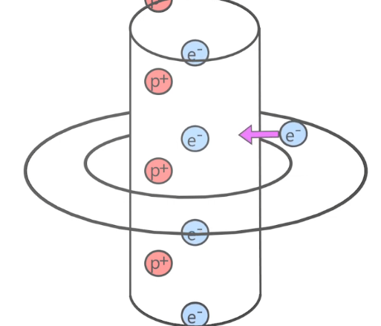
_______________________________________________
_______________________________________________
_______________________________________________
_______________________________________________
_______________________________________________
_______________________________________________
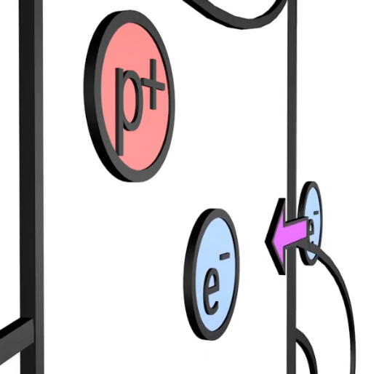
_______________________________________________
_______________________________________________
_______________________________________________
_______________________________________________
_______________________________________________
_______________________________________________
_______________________________________________
_______________________________________________
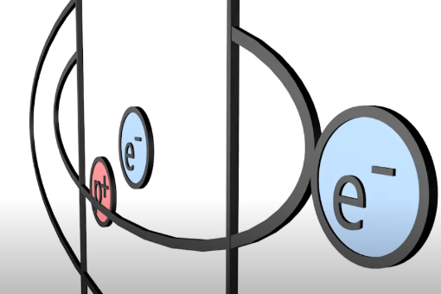
_______________________________________________
_______________________________________________
_______________________________________________
_______________________________________________
_______________________________________________
_______________________________________________

Aufgabe 2: Benenne die zwei Postulate der Speziellen Relativitätstheorie.
____________________________________________________________________________________________________________________________________________________________________________________________________________________________________________________________________________________________________________
Aufgabe 3: Erkläre, wie die Längenkontraktion und das „Stromkabel-Problem“ zusammenhängen.
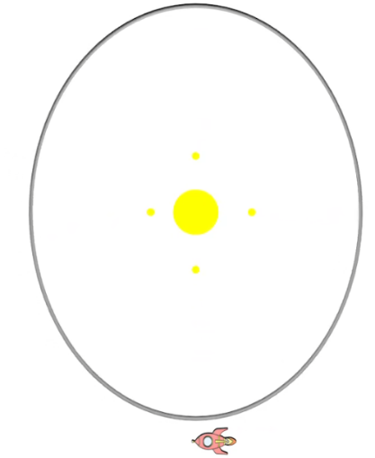
_______________________________________________
_______________________________________________
_______________________________________________
_______________________________________________
_______________________________________________
_______________________________________________
_______________________________________________
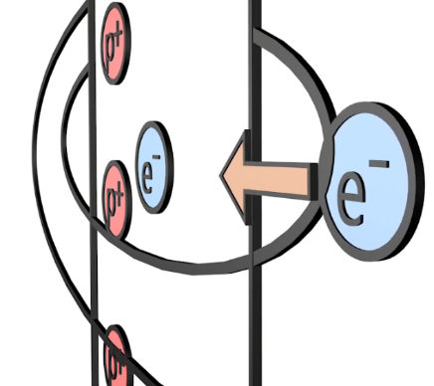
_______________________________________________
_______________________________________________
_______________________________________________
_______________________________________________
_______________________________________________
_______________________________________________
_______________________________________________

Aufgabe 4: Benenne die drei Effekte, die die Spezielle Relativitätstheorie vorhersagt.
__________________________________________________________________________________________________________________________________________________________________________________________________________________________________________________________________________________________________________________________________________________________________________________________________________________________________________________________________

